Peter Pan Jr

Welcome to our 40th Season of Entertaining Children and their Families
Mission Statement
The Mission of KCP is to:
• Entertain and inspire our audience by producing memorable musicals
• Create opportunities for the community to participate in high quality productions both on stage and behind the scenes
• Enhance development of youth in the arts by providing a variety of educational experiences in all aspects of theatre, supporting the Ontario Curriculum
• Celebrate the talent, commitment and achievement of our volunteers
Dear Educator,
As an organization that values the arts and education, we have created this study Guide as a resource for teachers. Our Study Guides are designed to be a valuable tool for teachers in two ways: helping you to prepare your students and enriching and extending their performance experience. Our goal is to serve principals, teachers and students in their pursuit of Ontario’s curriculum and to integrate the arts with your core curricular subjects.
About Kempenfelt Community Players Jr Productions
Our Young Company has been the recipient of Association of Community Theatres Central Ontario (Theatre Ontario member) THEA (Award) as follows:
- 2011 - 2012 – Anne of Green Gables – THEA (Awards) for Best Youth Chorus and Best Featured Artist (Jake Villeneuve)
- 2012 - 2013 – Honk Jr –THEA for Best Youth Chorus
- 2014 – 2015 – Seussical TYA –THEA for Outstanding Ensemble/Chorus Seussical, Outstanding Youth performer (Jarrett Stole) and Best Costume Design Seussical (Jessica Corner and Brooke Corner)
- 2016 -2017 – The Little Mermaid Jr – THEA for Outstanding Youth Ensemble
Ignite your imagination with the timeless story of the boy who wouldn’t grow up

Pre-Production Questions

- How many of you have experienced a live theatre performance? What did you see?
- What are some of the differences between going to the theatre and watching television or going to a movie?
- Theatre features live on-stage actors. They have spent many weeks rehearsing for the performance.
- The audience is a very important part of the performance. Appreciation and enthusiasm for the performers is shown by close attention and participation and applause at the proper times. The success of the play often depends on the audience.
- The theatre is a very special place. Its atmosphere is entirely different from your home where the television is always available.
- It is easy to identify with live actors. You can see how they use their bodies and voices to convey different emotions.
- Actors wear clothing and make-up to help create the impression of the characters they play.
- There is much more to most live performances than actors. Special sets, effects, lighting, music, costumes, and of course, the audience add to the total experience.
- Introduce your students to the following theatrical terms:
Box Office • Reserved Seats • Acts & Scenes • Producer • Program • Overture • Spotlights • Costumes • Props • Director • Stage • Curtain Call • Stagehand • Lobby • Usher • Musical Theatre • Proscenium arch • Playwright • Scenery • Makeup • Actor •

The Role of the Audience and Proper Theatre Etiquette

- Arrive on time so that you do not miss anything and so that you will not disturb the rest of the audience while trying to get comfortable in your seat. After the lights go out finding your seat is very difficult.
- It is easier for you (and the rest of the audience) to see and hear the performance if you stay in your seat and listen very carefully.
- In this theatre you are not allowed to eat or chew gum, only bottled water is allowed. Not only does it ruin the theatre, but it also distracts from your concentration.
- Try your best to remain in your seat once the performance has begun There is no intermission in a performance of KCP’s Young Company productions.
- Although you may wish to say something to the actors while they are on stage, you need to hold your thoughts. You may disturb their concentration.
- Listen to how the music sets the moods and affects your own feelings.
- Show the cast and crew your appreciation for their hard work with applause. Do this when you like a song or dance or joke at the end of the show.

Post Production Questions
- MUSIC
Was the music used in the performance live or recorded? How could you tell? Did it help develop the plot? What types of music was used, or was different types used?
Can you describe how different kinds of music would make you have different kinds of feelings?
When a play is a musical, an actor must have additional skills. Can you name some?

- SETS
Describe the sets used in the show you just saw. What props or details were used to suggest specific times or settings? How could lighting be changed to create a mood, season, time of day, etc.? What materials might have been used in building the sets? How were the sets and props moved on and off the stage? Describe a simple scene (a day in school, a trip to the mall, a ride in the car or on the bus), ask students to describe a basic set for the scene.

- COSTUMES
What would you need to know to create costumes for a show (Historical research, sewing, theatrical effects, etc.)?
Why is the right costume important to the character in the play?

- DANCE
Describe the kind of dancing, if any, in the production. How is it different from the kinds of dancing that the class might know? What purposes could dance have in a play?

Make a list of all the personnel needed for a play. (director, music director, producer, actors, musicians, author, designers-set, costumes, lights & sound, stagehands, choreographer, producer, etc.)

Reading Standards for Literature Key Ideas and Details
- With prompting and support, ask and answer questions about key details in a text. 1. Ask and answer questions about key details in a text.
- With prompting and support, retell familiar stories, including key details. 2. Retell stories, including key details, and demonstrate understanding of their central

Author! Author!
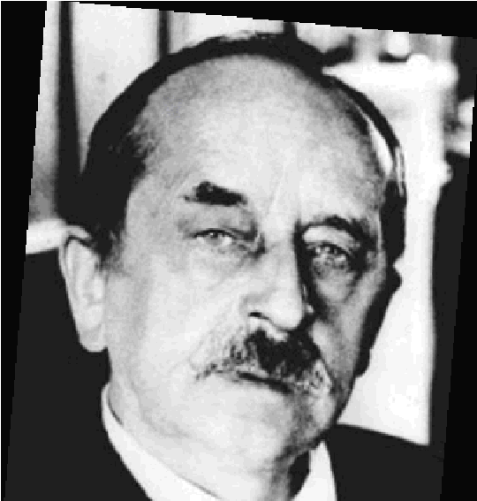
Sir James Matthew Barrie was born on May 9, 1860, in Scotland. He was the son of a poor weaver, David, and his wife, Margaret Ogilvy Barrie. Barrie was the second youngest of ten children and one of only several to survive infancy. When Barrie was six-years-old his elder brother, and Margaret Barrie’s favorite son, died. Barrie then became the new favorite, the apple of his mother’s eye. His mother ensured that he
received an education, and the playwright eventually received his M.A. from Edinburgh University in 1882.
Soon after graduation, Barrie began his writing career as a journalist in London. Then, in the early-1890s, Barrie published several novels and short stories. In 1891 Barrie also began writing plays. From 1901 until 1920 he wrote one play per year. Barrie’s best–known work Peter Pan was first produced in 1904.
The play Peter Pan had its roots in a novel Barrie published in 1902, The Little White Bird, which he wrote for some young friends, the Llewelyn Davies boys. Barrie met the family in London’s Kensington Gardens in 1897 and was immediately enamored with the three young boys, George, Jack, and Peter, as well as with their mother, Sylvia. Barrie befriended the Llewelyn Davies clan, which soon included two additional sons, Michael and Nicholas. Barrie spent a great deal of time with the five boys over the years, and they inspired all his Peter Pan stories. When the Llewelyn Davies boys lost both of their parents to cancer, Barrie became their guardian.
After the success of the play Peter Pan Barrie continued writing notable plays. Most were adult dramas and comedies that frequently played with fantasy. Barrie’s success as a playwright allowed him to be generous with funds, and he often donated to individuals as well as important causes. Barrie’s great contribution to English literature was recognized in 1922 when he was awarded the Order of Merit, the grandest of British honours. In 1928, shortly after he received this honour, Sir Barrie donated the Peter Pan copyright to the Great Ormond Street Hospital for Sick Children. Barrie continued to write until his death on June 19, 1937, in London.

The Name PAN

Barrie chose the name Pan after the goat-foot god of Greek mythology, who is abandoned by his mother as a child and appeared to Faust with his pipes and Dionysian maenads, the “Wild-folk”, who “know what no man else doth guess”. Pan is also of course the origin of the European Pied Piper myth, in which all the children of Hamelin are stolen from their homes and led into the mountain. In Barrie’s original notes for the play Peter is called “a demon boy, villain of the story.”

Peter Pan, which was alternately titled ‘‘The Boy Who Would Not Grow Up,’’ was first performed in London, England, on December 27, 1904, at the Duke of York Theatre. It has since become one of the most widely performed and adapted children’s stories in the world. It is also Barrie’s best-known work, though he was a prolific author writing in many genres. Critics believe that one reason Peter Pan was successful from the first is that Barrie combined fantasy and adventure in a way not done before. The play offers a fresh means of storytelling that appeals to both adults and children. While children enjoy the imaginative story and flights of fancy, adults can relate to Peter Pan’s desire to forego mature responsibilities and live in the moment. Roger Lancelyn Green wrote in his book Fifty Years of Peter Pan: ‘‘Peter Pan is the only children’s play that is also a great work of literature.’’

Discussion/ Journal Questions

* Have the children write a journal that will become their "ship's log."

All Ages
- What do you think about living forever as a kid and never growing up? Would you be interested in doing that? What are the good parts of that? What would you miss if you never grew up?
- Peter Pan is also about the idea of "play vs. work". Do you still make believe, pretending you are Peter or Wendy or Hook? At what age do you think we start to tell children to stop pretending? Do you get embarrassed when someone catches you playing make-believe? Do you think we should always be able to pretend? Do you think we let boys or girls play pretend longer? When do we start to think it's babyish?
- Neverland is a fantasy world, but it is not perfect. There is danger there in the form of the pirates and the crocodile. Can you imagine a perfect world?
- What does Wendy bring into Peter and the Lost Boys' lives? What good qualities? (i.e. Kindness, Generosity, Organization etc.)
- The kids go to bed and then the whole adventure starts when Peter arrives. Do you think it's like a dream? Do you remember your dreams? Have you ever had a dream where you were flying? Or one where you were chased by pirates?

- What do you think about the idea of having a dog baby-sit you like Nana, the Darling's dog in the story? Have you ever had a pet that you felt took care of you in ways, too? Do you know pets that care for humans like humans for children?
- What is it about being able to fly like birds without a plane that is appealing to humans? Describe how you think it would feel to fly away in the night to another place far away.
- Which group in Neverland of the three, the Lost Boys, the pirates, the Indians, would you like to play with? Which character in that group most appeals to you?
- The Lost Boys eat imaginary food in Neverland. It seems that no one ever gets hungry or tired. Does that appeal to you?
- What is a world without adults to you? Fantasy? Nightmare? Boring?
- What lesson do the Darling Children learn about their home and family by the end of their adventure?
- Now that you have seen this show, do you think your class could put on a play? What story would you tell and how would you tell it?
Write opinion pieces on topics or texts, supporting a point of view with reasons. Make connections between the text of a story or drama and a visual or oral presentation of the text.

Activities

We all have a place like Neverland in our own imaginations. A place where time stands still and everything is just the way we want it to be. Draw a picture of what your Neverland looks like as you see it.

- What would Tinkerbell look like if we could see her? Does she resemble other characters that we know? Or does she have another worldly shape and color?
- Draw what you see when you think of Tinkerbell the Fairy.

- Read a simpler version of Peter Pan and have the students sequence the events by creating a flap book. The fronts of the flaps are labeled First, Next, Then, Finally. Students write and/or illustrate the events in the book.

- Write a sequel to Peter Pan.

- Cast your favorite actors in a movie version you are directing. Would you change the look of the Darling home? The locale? The year? How would you enhance Neverland for the movie going public? Would you add more special effects?

- Write a biography for your favorite characters in Neverland. Tell us their past. Where did they live before we saw them? What happened to them that put them there in Neverland?

J.M. Barrie, author of the novel, Peter Pan, put elements of his own life into the book. He took a sad reality and turned it into a fantasy. Take something in your life and write a fantasy story that goes exactly as you would want it to.

Compare two or more versions of the same story. Analyze the structure of texts; supporting a point of view with reasons: Write opinion pieces on topics

Oral History Lesson

The story of Peter Pan is more than 100 years old. There are stories people have been telling each other for thousands of years. The stories we choose to keep around have a lot to do with making certain patterns of behaviour more (or less) acceptable to us.

- Think of an old story; say a fairy tale like Hansel and Gretel. There is a lesson in that story about bravery and devotion – the sister, Gretel, saves her brother’s life because she stays with him and finds a clever way to get rid of their enemy.

- List on the board: some of the things you think the story of Peter Pan has to say.

- These are likely the reasons it is told so often. Discuss whether and why you think this story should or shouldn’t be told for another 100 years. Is it outdated or universal? Would the story work only in the Canada, the United States or Europe? Is there a place it wouldn’t work? (There are no wrong answers.)

ACTIVITY

Ask each student to recall a story told in his or her own family or neighbourhood. Allow an overnight – let the students ask their families for stories. Usually these stories start something like, “When your grand-parents first came to this country…” or “When you were very small…” or “Once when we were traveling to see your Aunt Jennifer…” These stories pass down the virtues and silliness of families and the people in them.

FIRST: Have each student write out the story. Ask them to keep in mind exactly how they heard it. If they want to add details to it, they may, but make sure the goal is to “pass the story on” to new hearers.

THEN: Ask the students to list a couple of things they learn from the story. Do they, for example, learn that bravery is a quality that is important to their family because their grandfather was brave? Do they learn that they have a reputation for being messy because of something that happened when they were small? Is their mother resourceful because she solved a problem when the family was traveling?

NEXT: Have each student write about how these lessons show up in how they think of themselves and others in their families.

FINALLY: Ask the student if they think this is a good story to pass on to another generation. Does it carry in it something they want to be part of the future?

EXTENSION ACTIVITY:
Have students read their stories aloud to the class.
AND/OR
Illustrate the stories and make a book out of them – either a large book containing all the class stories, or a personal storybook that could even be given as a gift to someone at home.

Write narratives to develop real or imagined experiences or events using effective technique, well chosen details, and well-structured event sequences.

Shadow Activities

People have been telling stories with – and about – shadows for many centuries. It is an ancient form of art, yet Peter Pan gives it a new twist and combines it with live action. As long as there is light, there are shadows, and they change from moment to moment, and yet never lose who/what they are. This is a perfect medium for telling the story – filled with magical fantasy – of the boy who never ages while those around him change and grow. Think of it: Are you young? Change the angle of the light and see your face old. Are you old? Cast your shadow on the wall and dance like a child. Are you big? Stand under a light and your shadow is tiny. Are you small? Stand in front of a light and your shadow fills the world! Both real and fantastic, shadows are the element of Neverland.

Make sure your students understand the basics of shadow making:

1. A shadow is made when you [B]
- turn off the lights.
- block light with an object.
- turn on the lights.

When a thing is closer to the light its shadow gets [C]
- smaller.
- crooked.
- bigger.

When the sun is behind you, your shadow is [A]
- in front of you.
- behind you.
- beside you.

If possible bring a light into your classroom and:

- Experiment with casting shadows with various objects and your own bodies
- Make objects have conversations with each other
- Tell a story with shadows of things and people
(You will need simply a strong light source shining on a blank wall in a room that you can dim significantly. It doesn’t have to be dark, however.)

Here are two outside shadow games for a bright day:

- Shadow Tag: Try to “catch” each other by stepping on each other’s shadows. No touching of actual bodies allowed.

- Shadow Friends: Find the shadow of someone and let your shadow shake its hand or give it a hug. Again, no touching of actual bodies allowed.

For a more scientific shadow experience:

- Turn on the lamp, turn off the overhead lights, and ask students to observe the student's shadow being cast in the classroom. Ask them where the light source is and where the shadow is cast.

- Demonstrate how to trace the shadow by following the outline of the student's shadow with your finger or a pointer.

- Explain that in a moment each student will use chalk to trace the outline of his or her partner’s shadow outside.

- Tell students that after the tracing is complete, they can use pencils to draw their partner, his or her shadow, and the location of the Sun on a sheet of paper.

After students have drawn on their work sheets they can add more detail in the classroom.

Outdoor Activity
Remind students NOT to look directly at the Sun, but to concentrate on the shadows.

- In pairs, students spread out over a concrete slab or on the sidewalk.

- Distribute chalk.

- Ask students to position themselves to make shadows.

- Begin tracing by outlining partner's shoes--this is especially important if doing the extension activity in this lesson. Write the initials of the tracer beside the tracing.

As students complete the shadow tracing with chalk on the outdoor surface, distribute paper and pencils for them to draw/record their chalk outlines.

Make sure that each student gets the opportunity to create a shadow and document the shadow of a classmate.

Extension Activity: Changing Shadows

Two or three hours after students have completed their first shadow tracings, explain that they will go outside again to observe their partner's shadow and make tracings of what they see.

Return to the playground and ask students to find their shadows.

Distribute chalk. Remind students again, NEVER to look directly at the Sun, but to concentrate on the shadows.

Have students reposition themselves in their original locations, using their shoe outlines, marked by initials, as a guide.

Ask students to complete the second shadow tracing.

Redistribute student drawings and have students add the second shadow.

The following questions can guide a discussion of what students observed:
- Did anything change in your tracings? What looks different?
- What do you think made the shadows move? How can you explain that?
- Did the Sun move? Did we move? (Of course, we moved! Explain to students that shadows move because of the Earth's motion.)
- Discuss how these same principles made the shadows in Peter Pan change from moment to moment. What can you deduce about the light source/s in relation to the actors?
Extension extended: Explore how shadows can tell time by making a sundial.
Complete instructions can be found at:
www.eyeonthesky.org/lessonplans/14sun_sundials.html

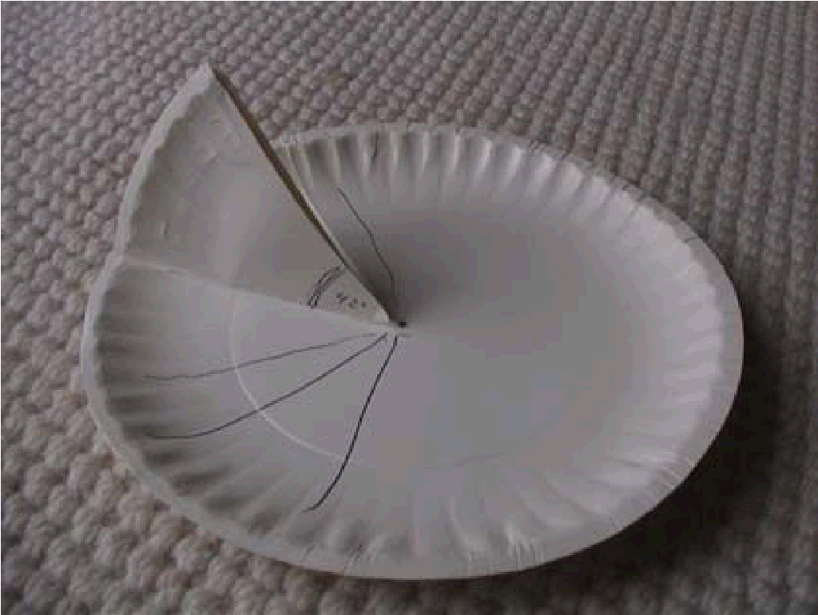

Understand the fundamental concepts, principles and interconnections of the life, physical and earth/space sciences.

GROWING UP – OR NOT

One of the central questions in Peter Pan is: What does it mean to grow up? It’s about as easy to answer that question, as it is to put a shadow in your pocket.

ACTIVITY: Make a piece of poetry contrasting images often associated with growing up.

FIRST: As a class, work together to make two lists of words. One list is of the great things about “growing up” and the other of not-great things associated with “growing up”. (Some of these can be the loss of the great things associated with being a kid.) Include objects as well as ideas.
For example: Great – go to bed late, have money, fast car, fire starter Not great – must pay bills, don’t ever get to play, heavy briefcase, neckties
This is raw material to use/expand as students write the diamante poems below.

EXPLAIN: A diamante gets its name from its shape. If you center your lines of poetry above and below one another on the page your poem will be diamond shaped. The shape emerges because the middle lines are longer than the first and last lines. It will look something like this.
1. ____________
2.___________ ___________
3.___________ ___________ ___________
4._______________________________________________________
5.___________ ___________ ___________
6.___________ ___________
7.___________

Write routinely over extended time frames and shorter time frames for a range of discipline-specific tasks, purposes, and audiences.

Writing the Poem

Have each student write the poem as follows, adapting words and phrases as they wish:

Line 1. Write “Growing up” or a similar phrase (Getting old or Done with kid stuff).

Line 2. List two objects from the negative side of growing up.

Line 3. List three other things from the negative side of growing up.

Line 4. Write a phrase that expresses that it might not be that way at all.
For example, you could use: “But maybe it isn’t all bad.”

Line 5. List three of the activity type things from the positive side of growing up.

Line 6. List two of the objects from the positive side.

Line 7. Repeat line one.

EXAMPLE:
Done with kid stuff
Bifocals and knitting needles
Can’t play kickball, worrying about bills, always in a meeting But what do I know?
Staying up late, making all the rules, driving a new car
I’ll wear diamond earrings, and eat filet mignon
When I’m done with kid stuff
FINALLY: Share your poems with your classmates by reading them aloud.
Extension Activity
- Illustrate your poetry with original or found art and compile all the poems into a booklet.
•Give your booklet a title, such as I Won’t Grow Up…Yet.
- Make a copy of the booklet for each student.

Your Address Using Geography Geometry and Time!!

Peter Pan’s address is “second star on the right and straight on to morning.”

This address combines three elements: geography, geometry, and time. We know something about Peter because of his address.

Have students write addresses for themselves that use these three elements (in whatever order they choose).

Ask them to reflect on what their “new” address says about them.

Example: Take a right at McDonald’s and zigzag down the basketball court until snow falls.

Geometry Identify and describe

Point of View

Think of an incident from the story of Peter Pan and tell it or write it three different ways:

from the point of view as a child

of a “middle aged” adult

of a person, more than 70 years old.

OR

Act out the incident three times with the same lines and characters, but at three different ages.

Assess how point of view or purpose shapes the content and style of a text.

Conflict/Resolution

Peter Pan and Captain Hook are enemies. Because we are meant to see more of the story from Peter’s point of view, he is called the “protagonist.” Captain Hook, because he works against the main character, is the “antagonist.” The conflict between these two is what makes the story of Peter Pan so interesting.

In this in-class activity, students will define, identify and discuss the conflict and resolution in the plot of a story.

MATERIALS NEEDED:
- Pencil/pen and paper
- Chart paper and markers

ACTIVITY:
- Introduce the terms “conflict” and “resolution” to the class. Split the class into small groups.
- Identify various problems (in small groups) that characters experienced throughout the plot of Peter Pan. Write down the problems, and identify them as conflicts.
- Create a class chart pointing out the previously identified problems, or conflicts, that affect the plot of Peter Pan.
- Participate in a teacher-led discussion about the idea that not all problems, or conflicts, are as bad as others. Review the class chart of conflicts trying to identify which conflicts are more severe.
- Have students vote on which conflict identified on the class chart is the main conflict from the story. *Teacher may need to take an active role in the discussion about conflicts prior to voting to make sure students understand the concept.
- Discuss how the main conflict was resolved.
- Choose 2-3 of the minor conflicts and identify IF they were resolved and HOW they were resolved. (Complete in small groups.)
- Share resolution results with class.

Demonstrate decision-making skills and responsible behaviours in personal, school, and community contexts.

Treasure Maps

To read any kind of map, one must understand some basics of geography. A treasure map is different from a map, say, in a textbook or atlas, because it often contains images of how the landform or landmark appears from nearby instead of from a bird’s-eye view.

In this activity, students will create their own treasure maps based on their knowledge of geography and the physical and human features of a given place.

MATERIALS NEEDED:

- Paper
- Markers/Colored Pencils/Crayons

ACTIVITY:
- Discuss maps and how they show geography. Discuss that when tracking someone’s journey over land or water, maps can help to show not only space, but time. (Ex. This is where they set up camp, this is where they found water, etc.).
- Discuss that how pirates have been known in history to leave a treasure map to find the treasure.
- Have students make a list of places a pirate might go (islands, beaches, oceans, rivers) and brainstorm some exciting events which might take place there.
- Students will then create their own treasure map with the materials provided, showing how following the map helps someone in the journey to find buried treasure. They should mark the location of the treasure with a large X.
- Students will present their maps to the class, pointing out the routes and obstacles a pirate would encounter on his/her way to finding each spot.

Identify physical characteristics of places, both local and global

Treasure Map Ideas

Coordinates Treasure Map

Use a piece of grid paper- place numbers vertically and alphabet horizontally

Learn directions

Describe the treasure using:

Adjectives
Similes
Metaphors
Alliteration

Characterization

Investigate character development through describing how characters look, talk or behave.

Captain Hook
‘He had two most evil-looking black eyes, his face was seamed with lines which seemed to express his wicked thoughts, his hideous chin, all unshaven, was as black as ink and as prickly as a furze-bush, his hair was long and black and it hung round his face in greasy curls. He was singing a horrible song about himself, keeping time by swinging in the air the gruesome stump of his right arm, on which a double-pronged hook was fixed instead of a hand.’

Activities
Starter – whole class – five minutes

* Pose the question ‘What is a pirate?’ Sentence ‘A pirate is…’ to be completed in six words (e.g. ‘A pirate is a robber who travels by water’). Project pictures/footage of pirates onto screen and/or listen to music.

Introduction – whole class – five minutes

Write the word ‘character’ on the board. Discuss character traits of people and the four different features of characterization – name, description, action, dialogue. Read description of Captain Hook – Do we know he’s a baddie from this? Then discuss the character traits of Hook.

Showing Not Telling!

Discuss the differences between: ‘He was an evil pirate’ and ‘With one swing of his cutlass he sliced off the trembling sailor’s ear.’

Imagine a pirate wants to steal all your money. What would he say? How would he say it? Each group member to write a sentence of pirate-like dialogue. Groups to assemble a pirate profile, using one contribution from each member.

Groups to share pirate profiles with the whole class, as dramatically as possible. Class to recall the four different features of characterization – name, description, action, dialogue.

*Tasks for extension
- Listen to ‘Jack Sparrow’ (the theme music to Pirates of the Caribbean 2). Consider its success in evoking character.
- Analyze description of Captain Hook, picking out features, that evoke character including imagery.
- Write a dull character profile using NONE of the features as discussed. Then write an exciting one!
- Identify stereotypical characteristics of pirates. Add details to your characterization that are NOT.

Read closely to determine what the text says explicitly and to make logical inferences from it; cite specific textual evidence when writing or speaking to support conclusions drawn from the text.

Pirate Talk

Different groups of people use their own words, or lingo, to communicate their ideas.
See if you can draw a line to match each pirate word with its correct definition.

- Ahoy: Hello!
- Steady: Hold On
- Doubloon: A gold coin
- Port: The right side of a ship
- Jolly Roger: The pirate flag with skull and crossbones
- Aye: Yes
- Mast: Tall wooden pole used to hold the sail
- Captain: The leader of a ship
- Starboard: The left side of the ship
- Shiver me timbers! Oh! my goodness!

Learn about the vocabulary of pirates. Create a dictionary or other journal of these terms. Compare pirate terms and the terms used today.

(http://www.geocities.com/marciateach/shivermetimbers.htm) Or go to
http://www.talklikeapirateday.com/translate/

to translate into pirate talk!!!

History of Pirates

When most people think of today’s pirates, they imagine Long John Silver and Captain Jack Sparrow. In fact, the first known pirates were the fierce Sea Peoples, who attacked Greece from the Aegean Sea in the 13th century BCE, stealing treasures and capturing hostages. In fact, the word “pirate” comes from a Greek word, “peira,” which has been taken to mean, “to find luck on the sea.”

By the time the 1st century BC rolled around, pirates were a part of everyday life. Pirates even kidnapped Julius Caesar at one point. In the Middle Ages, even when pirates were committing crimes, they were helping to change history. St. Patrick, the patron saint of Ireland, only ended up in Ireland because pirates kidnapped him and sold him into slavery when he was sixteen. He escaped, but later returned and played a huge role in converting the country to Christianity.

Perhaps the most famous pirates are the pirates of the Caribbean.
The golden age of piracy lasted from the 1560s to the 1760s. It was during this time that the pirate code was created, and from where our image of pirates as a rag tag group of brotherly buccaneers comes. The term “buccaneers” comes from a French word, “Boucanier,” a hunter that poached cattle and pigs and roasted them over a fire before going on the run from authorities. Not only did this lead to the word buccaneers, but also the word barbeque.

Today pirates still exist, and they are as dangerous as ever. They mainly attack cargo ships off the coasts of third world countries. The main change in the pirates of today is that in most cases modern pirates aren’t interested in the cargo itself, but in the personal belongings of anyone who might happen to be aboard. However, the most important change is that there are far fewer pirate attacks today than there ever have been. No matter what, pirates will always ride the high seas in our imaginations.

What is the Jolly Roger?

Pirates sailed under flags called 'Jolly Rogers'. The origin of the name has several possibilities: it could come from the French saying jolie rouge which meant "pretty red" or from an English expression for the devil: old Roger. Many pirates created their own designs and had women in the West Indies sew the flags for them. What a sea-traveler did not want to see was a ship's flag that was all red, for that meant 'no quarter given' (there would be no survivors of any attack), so in some ways it was better to see the Jolly Roger and know that there was a chance to live.

Design your own!

You are to design and create your own personal Jolly Roger, a pirate flag that will reflect something about you. It could be that you like to play guitar, so the Roger could have crossed guitars instead of crossbones!
Grab some markers, crayons, pens, or pencils, and get to it!

Pirate Dictionary

Pirate- To try, or to complete an attack on a ship. A thief of the seas, or oceans. Violence used to steal (by force) the property of another vessel to steal gold/treasure.

Privateer- An armed vessel sailing under the commission of a sovereign power against the enemy.

Buccaneer- A piratical adventurer of the sea. A person who plunders at the sea, or land from the sea.
Mariner- One whose responsibility it is to help in navigating a vessel.
Merchant ship- A ship that is involved in trade/commerce. A cargo ship.

Galleon- A large square masted vessel of the 1500's used for war, or commerce.

Booty- Goods obtained illegally. Spoils obtained because of war or battle.

Bounty- Reward or payment, usually from a government, for the capture of a criminal.

Loot- Gold, money, or other goods obtained illegally
Plunder- The act of pillaging or robbery.

Cutlass- A short, heavy, single edged sword, once used predominantly by sailors.
Mutiny- To rise against authority, particularly a naval or military power.

Maroon-to isolate. Sailors would leave mutinous shipmates on deserted islands, without any means of survival.

Jolly Roger- Typically a black flag bearing drawn white bones; indicates a pirate ship

Pirate Math Activity

Overview— Let’s face it, most pirates were in the pirating business for one reason only: treasure. Sure, they got to wear those cool hats, too, but gold, silver, and jewels were the plunder they were after. And if all the pirates wanted treasure, you can bet they fought over it sometimes.

Now here is your chance to win some treasure. But you don’t get off easy with swordplay. You must argue your way to it!

For Teachers— It might be expected intuitively that Pirate A will propose the allocation shall be 20, 20, 20 ,20. 20. However, this is not the theoretical result. In the game theoretic analysis, the allocation offered by Pirate A that would be accepted (assuming all pirates are rational and are capable of understanding scenarios that will occur when they accept/reject offers) is:
Pirate A: 98, Pirate B: 0, Pirate C:1, Pirate D: 0 and Pirate E: 1. This is apparent if we work backwards: if all except D and E have been thrown overboard, D Proposes 100 for himself and 0 for E. He has the casting vote and so this is the allocation. If there are three left (C, D, and E) C knows that D will offer E 0 in the next round; therefore, C must offer E 1 coin in this round to make E vote with him, and get his allocation through. Therefore, when only three are left the allocation is C:99, D:0, E:1.
When B makes his decision, he knows this; he must therefore make sure that he is not thrown overboard. He does this by offering 1 to D. Because he has the casting vote, the support only by D is sufficient. Thus, he proposes B:99, C:0, D:1. E:0. A, as a rational agent knows that this is the allocation of coins if he is thrown overboard. He therefore offers: a:98, B:0, C:1, D:0, E:1. hence the allocation which gives the most to A but will nevertheless be accepted is: a: 98 COINS, b: 0COINS, c:1 COIN

Directions

- Pick 5 people to be pirates (Give yourselves pirate names if you want).
- There is a strict order. Pirate 1 superior to Pirate 2, who is superior to Pirate 3, etc.
- You have 100 “gold coins.” These can be pennies, stickers, or whatever cool item you want!
- Decide how to distribute them.
- The most senior pirate should propose a distribution of coins.
- The pirates should then vote on whether to accept this distribution.
- The pirate who proposed can vote, and has the casting vote in the event of a tie.
- If the Pirate's proposal is approved by vote, it happens.
- If not, the pirate is thrown overboard and is out.
- The next most senior pirate makes a new proposal to begin again First, the pirates want to survive. Secondly, the pirates want to maximize the amount of gold coins they receive and, thirdly, they like throwing other pirates overboard. When all the pirates in a group can agree on who gets what, the game is over, and you’ll see if you walked away with your fair share.

Understand ratio concepts and use ratio reasoning to solve problems. Develop understanding of statistical variability.

Neverland

J.M. Barrie has said that Neverland would look different for everyone. Rather than pirates and mermaids, who would populate your
Neverland? Would it be made up mostly of jungle, or forest, or sea, or desert, or some other landscape? Who would be the villain in your imaginary world? Draw or write a description of your Neverland.

Ask the students if they can remember the names of all the characters in Peter Pan and list them on the board.

Ask the students what qualities they think you need to be a good citizen of Never Land and write them on the board too. Suggestions will hopefully include bravery, loyalty, being a good friend, respecting the environment, playing fair, being able to do things for your self, working together like the Lost Boys...

Ask each student to divide a sheet of lined A4 paper into two columns, one entitled Good citizens of Never Land and the other Bad Citizens of Never Land. They can decide which characters they think belong in each column and they should also provide a reason for each choice. Some characters may appear in both columns.
e.g.: Tinkerbell is a good citizen because she drinks the poison and saves Peter or Tinkerbell is a bad citizen because she tells the Lost Boys to shoot the Wendy Bird.

Flag

As far as we know Never Land doesn’t have a flag. If you were the King or Queen of Never Land, what might you include on its flag? Write any suggestions on the board.
Ask each student to design and color their own Never Flag the suggestions on the board for inspiration.

NEVER POEM

Discussion:
Ask the students what they think they would like about living in Never Land and write their suggestions on one side of the board. Now brainstorm the names of all the Peter Pan characters onto the other side of the board.

Exercise: Ask the students to get into groups of 4. Ask each person in the group to pick a different character from the board, ensuring that between the four of them they have all selected different characters. Each student should then write down on a piece of paper, one sentence, in the first person, that encapsulates what that character feels about Never Land.

When they have completed this task, they should take it in turns to read their sentence out to the other 3 people in their group. They should then construct the four sentences into a Never Poem. This means they need to decide the best order for the statements they have written. Which would make the best opening line? Which would make the best end sentence? They should then practice reading their own statements in the agreed order. Each group should then perform their group’s Never Poem to the rest of the class.

Themes

Good and Evil
There are several variations on this conflict, one being the battle between individuals representing ideologies, and the other being the inner struggle in characters between good and evil. Discuss the battle between Peter and Hook and the internal battle between Tinkerbell and her conscience.

Fantasy and Reality
Often described as the conflict between what is true and what a character imagines to be true. Deep rooted real-life fears often manifest themselves in a character’s fantasy life. The same actor who portrays Mr. Darling often portrays Captain Hook; Discuss the significance of that choice.

Improvisation
Have students act these out!
- One night, when you are sleeping, flies into your room, awakens you, and asks you to fly away with him/her to a place where there are no adults! Do you go? Would you leave a note? Would you wake up your brothers and sisters and take them along? Would you call and tell your friends you'll be by to pick them up? Improvise the possibility in a small group.

- Once in Neverland, Improvise first in small groups as residence of Neverland,
i.e. Lost Boys, Pirates, Indians etc. Then add a new group of modern children from “the real world” who are new to Neverland. What would a modern kid take to Neverland? How do the residence of Neverland help the new kids to identify with their way of life?

- Break the class up into groups of 3-5 students. Give them 10 minutes to decide what are the main Five points or events in the story. The group will create tableau pictures (frozen poses that tell a story) to represent each of their main points. Have one person narrate the caption of each tableau. Like a living picture book. Have each group take turns their tableau story and watch each group in turn as they quickly go from one frame to the next, freezing only ten seconds or so in between each to let the audience see. This exercise is lots of silly fun, but it quickly lets us all discuss what we think are the main events or plot points in the play.

- Describe how you think it would feel to fly like Peter Pan. Make sure you try to use all five senses in your description of the experience!

The Big Ideas in Peter Pan:

- The stories we pass from generation to generation are invaluable.

- Shadows are capable of wild transformations in perspective…so are we.

- Growing up is not all about time.

- Courage counts, and every one of us can live up to our convictions.

Extension Activities

*Students may do a research project on pirates. Find out what famous historical figures that fit the definition of pirate.

*Investigate the types of pirates that have existed throughout history.
Give examples of each kind. Links-
(http://geocities.yahoo.com/marciateach/nortoriouspirates.html)

- Learn about a pirates' "code of conduct". Have your class create their own code. Using a Venn Diagram compare the two codes. Discuss why countries have rules and laws, and what happens to people who choose not to obey them. Discuss this same concept among pirates. Compare the consequences.

- Create an Illustrated Pirate Dictionary.
(http://geocities.yahoo.com/marciateach/piratevocab.htm)

- Learn about the vocabulary of pirates. Create a dictionary or other journal of these terms. Compare pirate terms and the terms used today.
(http://www.geocities.com/marciateach/shivermetimbers.html)

- Research clothing worn by pirates in the years after the colonization of Canada. Write a report, including illustrations, dioramas, or mobiles demonstrating what you found.

- Investigate and research the different kinds of ships used by pirates. Do pencil sketches of these ships; create a poster from magazines or other media.

- Read and make a book report from one of many fictional or factual books listed about pirates, pirate ships or pirate voyages. These reports could be oral, using art medium or using technology.

- Working alone or with a team write a play or puppet show staring pirates. Give this play for your class, or another class.
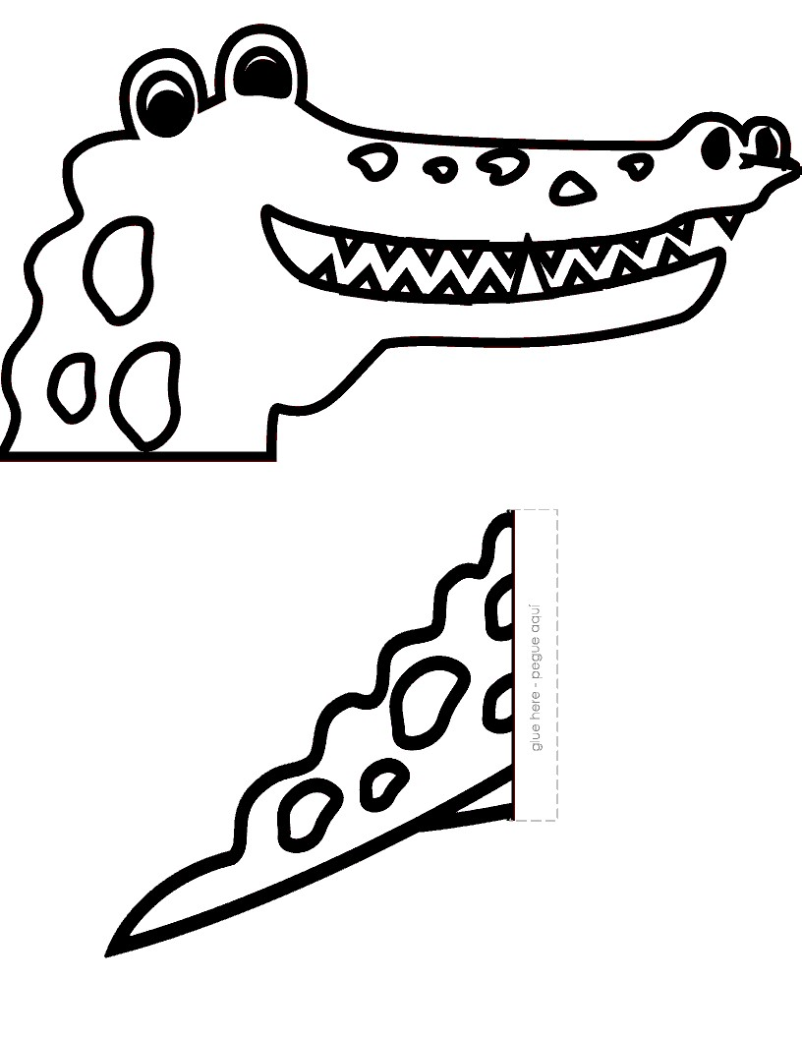
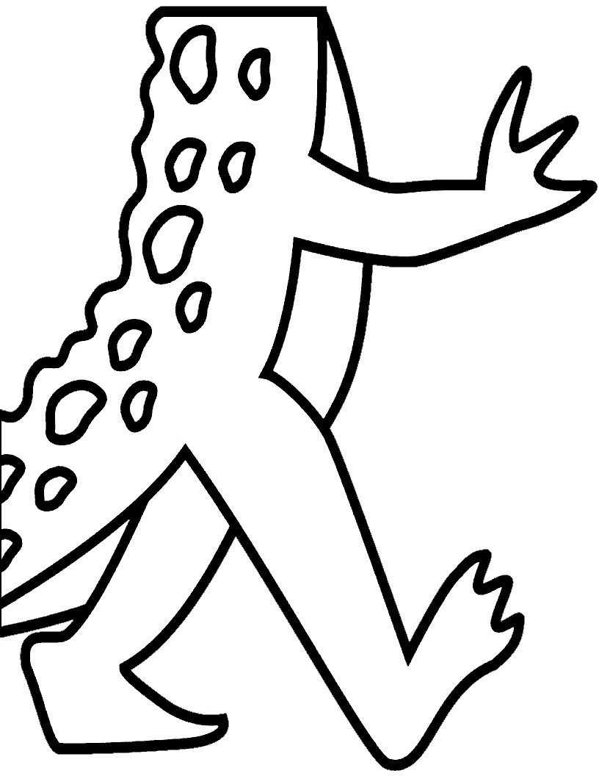

Crocodiles

Video describing differences between alligators and crocodiles

http://www.youtube.com/watch?v=h8CHXW0IKqk

Read the book The Enormous Crocodile by Roald Dahl

Go to
http://kids.nationalgeographic.com/kids/animals/creaturefeature/nilecrocodile/ to find out about crocodiles

Color and make a puppet using alligator cut out
Use a flat paper bag
Cut out Crocodile
Glue to bag
Or Glue to craft sticks

